Have created a table Olympics and have loaded the datum from Olympic_data.csv using load command.

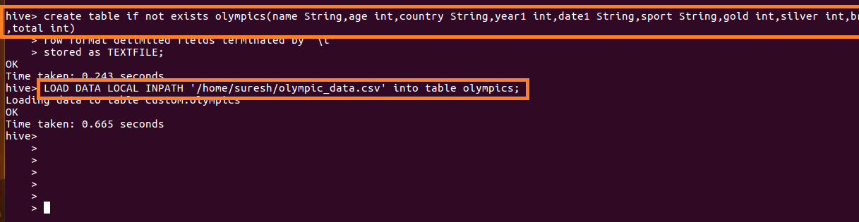

Write a Hive program to find the number of medals won by each country in swimming.

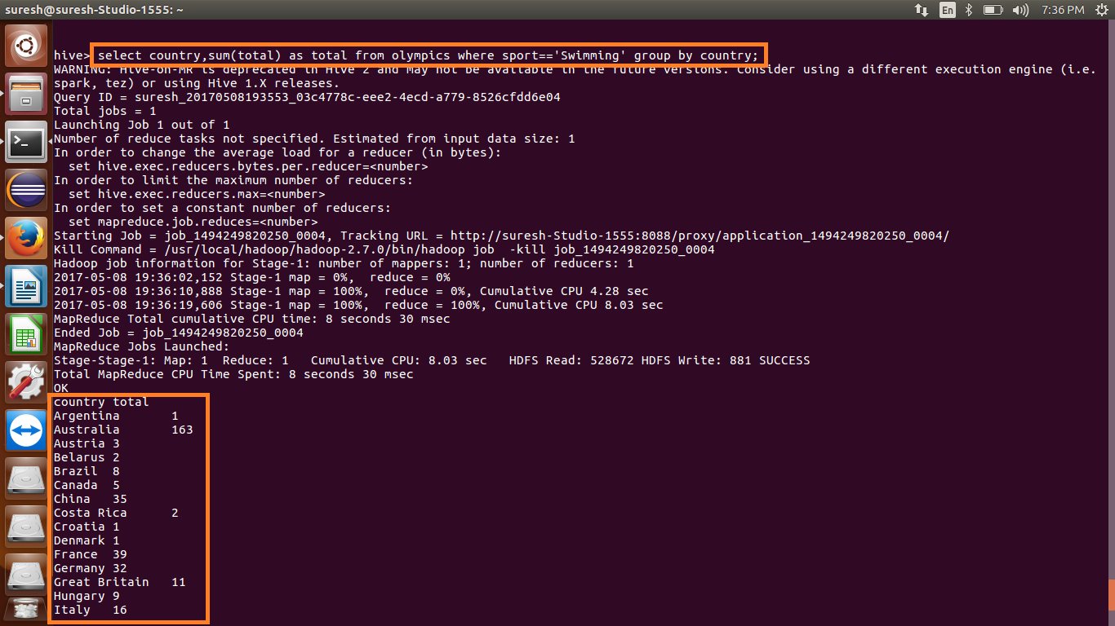

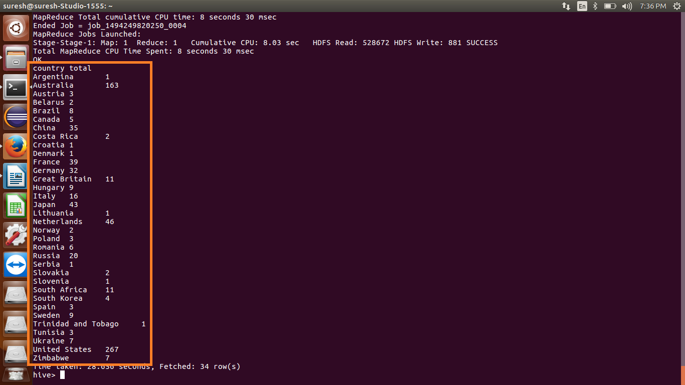

Write a Hive program to find the number of medals that India won year wise.

